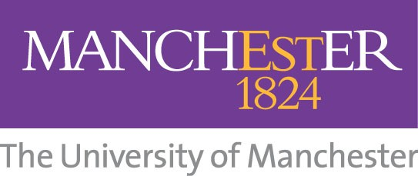

영국 명문 맨체스터 대학교의 School of Chemical Engineering and Analytical Science 소속 연구센터인 Centre for Process Integration에서는 매 년 5-6명 정도의 박사과정 학생에게 장학금(3년간의 박사과정 학비 및 생활비)을 지원해주고 있습니다. 지원자들이 많아 선발과정이 매우 엄격하지만, 관련 분야 전공 학생들에게는 매우 중요한 정보가 될 수 있을 것입니다.

화학공학 분야(세부 전공: 화학 공정 설계, 공정 합성, 에너지/환경 공정디자인),
혹은 관련 분야(환경/에너지)에 관심이 있는 분들은 좋은 기회로 활용하시기 바랍니다.
장학금 지원 및 문의는 연구 센터로 직접 하시면 됩니다.

센터에 대한 자세한 내용은 다음 홈페이지에서 보실 수 있으며, 하단에 연구 센터에 대한 간단한 소개 및 연구 프로그램 첨부합니다. 참고하세요.
http://www.ceas.manchester.ac.uk/research/researchcentres/centreforprocessintegration/

맨체스터대학교 한국사무소
Manchester, Nottingham, Warwick Universities Korean Office
Suite 503 Ssangyoung Platinum Officetel,
Jeokseon-dong 156, Jongno-gu, Seoul 110-052
Tel. 02 730 5771/ Fax. 02 730 5772
Email. support@mnwkorea.com
http://www.mnwkorea.com

************************************************************



Centre for Process Integration
The Centre for Process Integration (CPI) within the School of Chemical Engineering and Analytical Science of The University of Manchester, is a world leader in the field of conceptual process design. The methodologies developed allow environmentally friendly process design with the most efficient use of raw materials, energy and capital. The Centre enjoys an outstanding international reputation for the quality of its work, gained from many years of successful research and technology transfer.

CPI Research Programme
In the past, the major research emphasis in process design has been placed on the analysis, or simulation, of processes. The synthesis of processes, or process integration, has in comparison received little attention. The Centre for Process Integration is dedicated to the development of design methodologies in the field of process integration.

The origins of the Research Programme in the early 1980s were rooted in energy conservation. Today the programme has broadened to take account of the drive towards greater efficiency in the use of raw materials in general and of increasing pressures to design process which are environmentally friendly. An objective that runs through all aspects of the Programme is the efficient use of capital. Despite the fact that the Programme has broadened in its scope and objectives, the tradition and values that were established in the early days of the Programme in the field of energy conservation have been maintained. Our objective is to develop as deep an understanding as possible of the physical principles that underlie process integration problems. Once the principles have been understood, our objective is to then develop these into practical methodologies, employing the necessary mathematical algorithms.
Our methods attempt, where appropriate, to maintain a two-step approach to solving process integration problems. The first step sets performance targets. Such targets can be used to scope and screen many design options quickly and efficiently. Once the required options have been selected, the second step provides systematic design methods to allow the targets to be achieved in practice.
We traditionally follow our methodologies through to their first applications to ensure that the methodologies are indeed practical and do meet the requirements of process designers. To enable this we work closely with members of The Process Integration Research Consortium.
Our Research Topics page describes the Research Programme in Process Integration at UMIST, which is devoted to four broad research themes: efficient use of raw materials, energy efficiency, emissions reduction and process operations. All four themes emphasise the efficient use of capital throughout.
If you require any further information on any of the projects listed on this site, please contact us .
####

